

**ITC 6000 CRN 70346**

**Database Management System**

**Project Report - HIV in Latin America**

**Professor Na Yu**

**Submitted by:**

# Aditi Rajmane

# Akshay Vibhute

# Ayushi Walia

# Buqing Zheng

# Shengjia Wu

# Varun Shah

# Zhecheng You

# **Date: December 7, 2022**

# Introduction:

We have performed data analysis on the HIV data for Latin America from 2007 to 2016. Latin America is divided into three regions: South America, Central America, and the Caribbean. We have focused only on the South American region. There are a total of 12 countries in the South American region. The dataset contains data about all 12 countries on the estimated number of people living with HIV, the estimated number of people dying of HIV, the number of women having HIV, the mother-to-child transmission rate, and the percentage of pregnant women with HIV.

To understand health behaviors, health outcomes, and HIV transmission among people living with HIV, it is crucial to consider employment as a social determinant of health. The relationship between employment and HIV in the region of Latin America is examined in this report. Understanding the evolving nature of HIV in Latin America and the difficulties associated with unemployment and the region’s GDP ratio from 2007 to 2016 is the main goal of this essay.

Datasets were obtained from various sources, such as the World Bank, UNICEF, and the World Health Organization. We have divided the data into two different CSV files. One CSV contains information about HIV, and the other contains information about GDP and population.

# Analysis:

Datasets obtained from various websites were merged, and the final datasets were cleaned. The cleaned datasets were uploaded to the DB Browser through the import wizard under the HIV_Latin_America database. Two CSV files, "HIV_Data" and "GDP_Data," were imported into the "HIV_Latin_America" database.



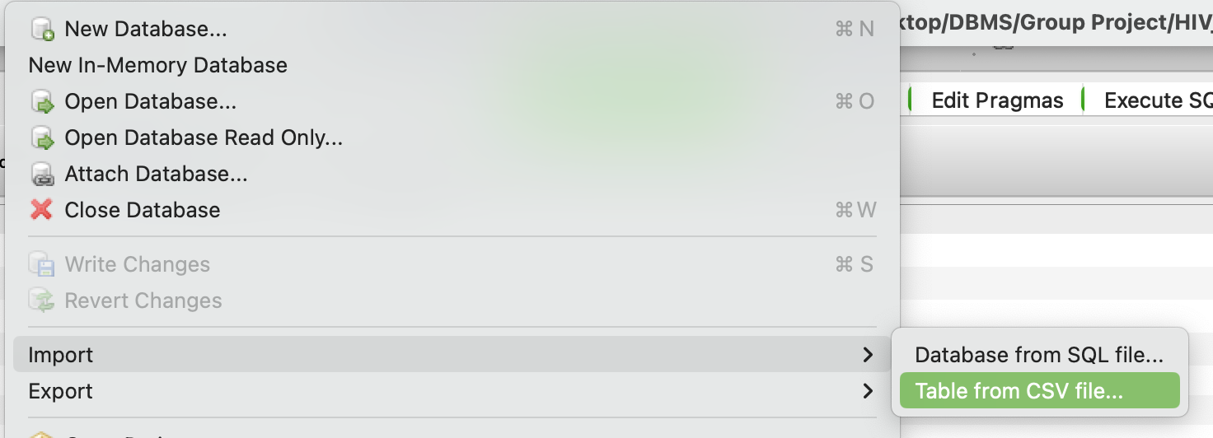

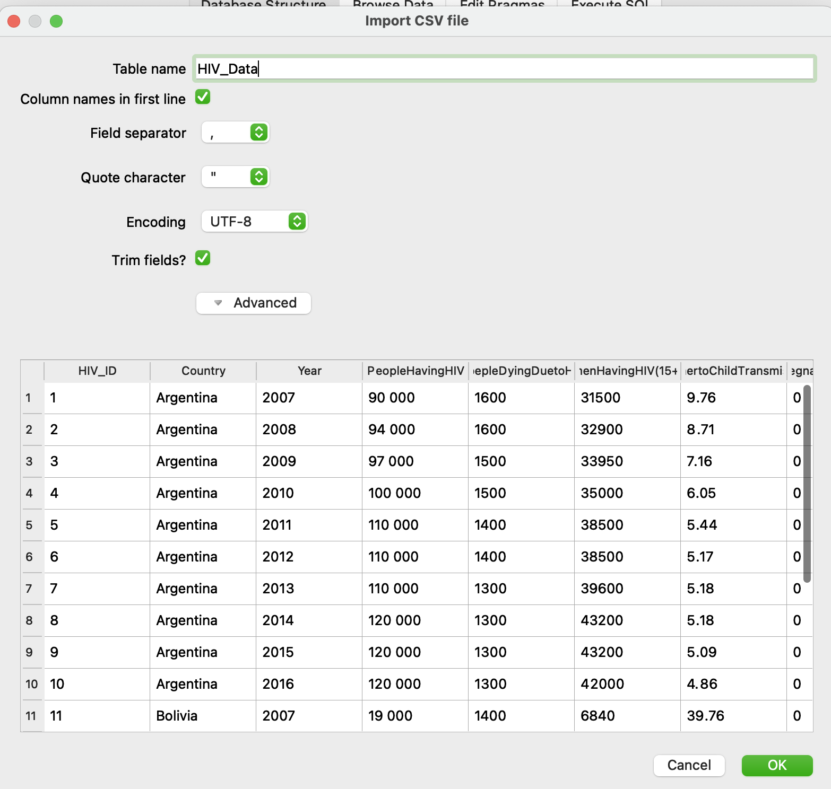

A few attributes' data types were changed from text to integer through the modified table’s function. HIV_ID and GDP_ID were made primary keys. Primary keys were used to join the two tables, "HIV_Data" and "GDP_Data." The column names "%ofPregnantWomenHavingHIV" and "WomenHavingHIV(15+yrs)" were changed to "WomenHavingHIV," and the column name "GDP (current US$)" was changed to "GDP."

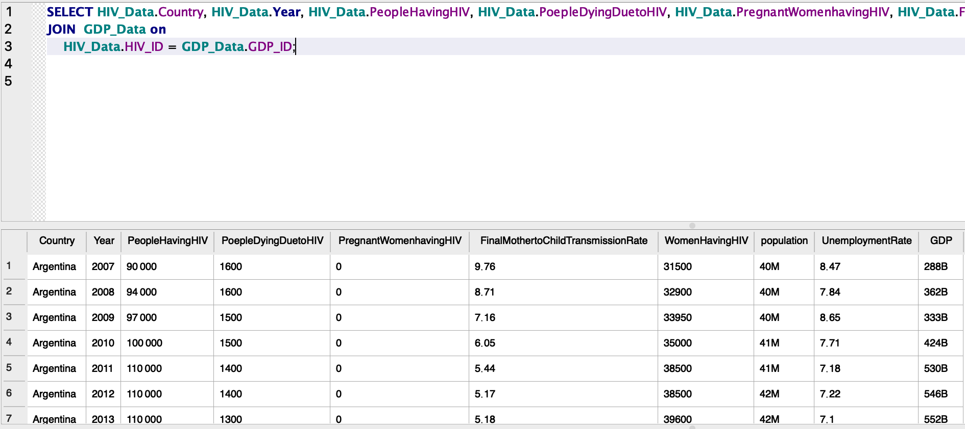

The percentage of people dying and people living with HIV was calculated by performing a calculation in SQL as follows:

Percentage of people living with HIV = round ((HIV_Data.PeopleHavingHIV / GDP_Data.population) / 100,2)

Percentage of people dying with HIV = round ((HIV_Data.PoepleDyingDuetoHIV / GDP_Data.population) / 100,2) as Percent_dying

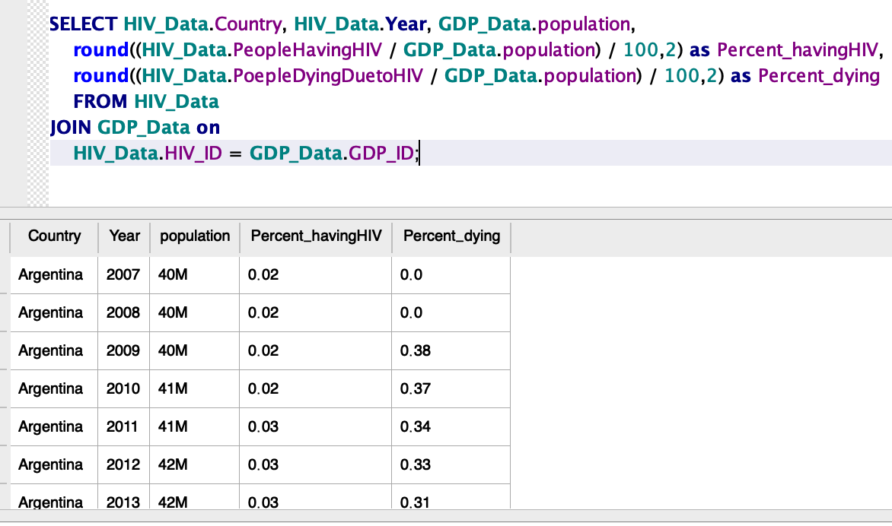

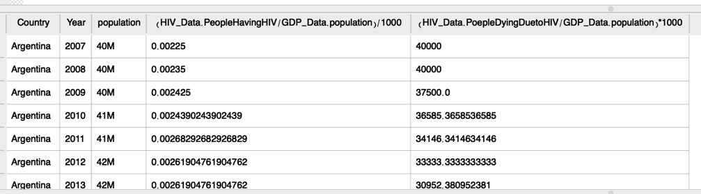

GDP per capita is calculated by dividing a country's GDP by its total population year after year.

GPD per capita = round (GDP_Data.GDP/ GDP_Data.population,2)

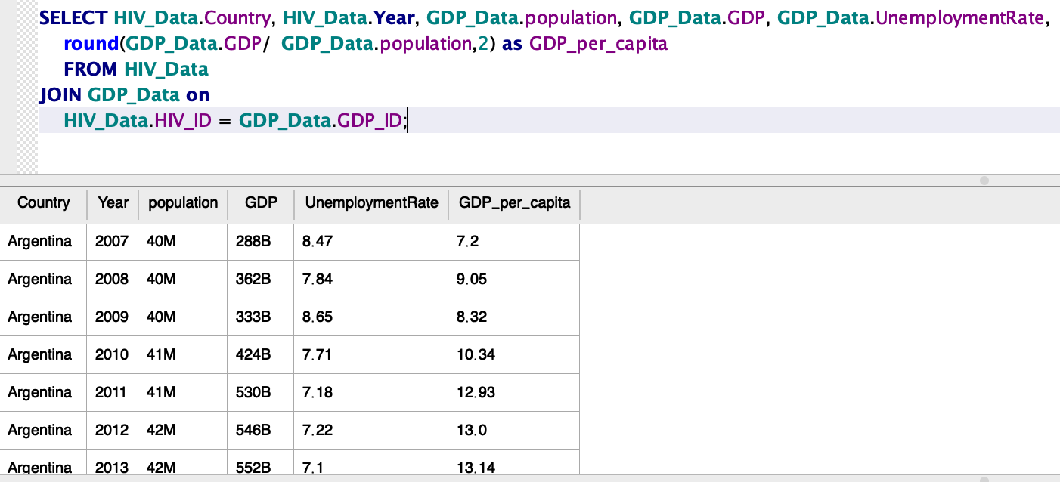

**Data Visualizations:**

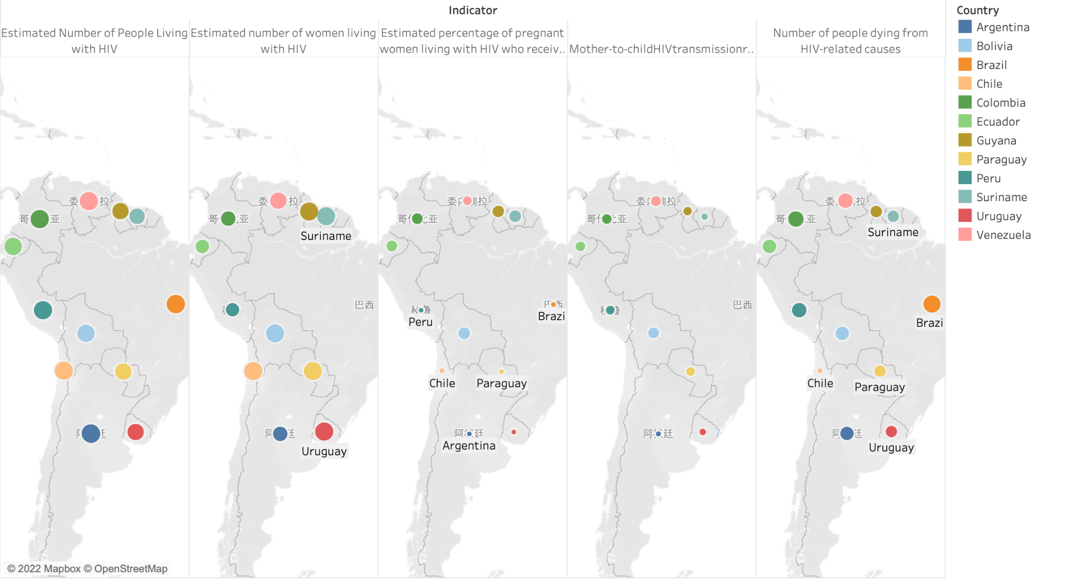

The dot chart above shows the countries we are researching, with the color labels that estimate people living with HIV in such regions.

1.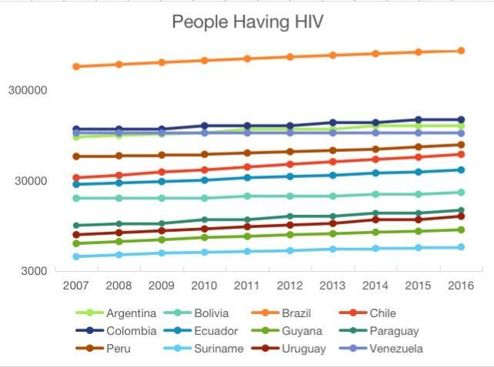

The line chart (people having HIV) illustrates the information of the number of people living with HIV in 12 South America countries. Which is part of the Latin America region we are researching, and we included all the countries in this region. Since the subject of this study is the countries, the colonies of France and Britain are not in our objects. Only considering the absolute quantity of the population that has been infected by HIV, the highest number occurs in Brazil, which is also the largest country in population which belongs to this area. And people living with HIV in Suriname is the minimum, according to their total population, this is also normal. Data from this graph didn’t surprise us.

2.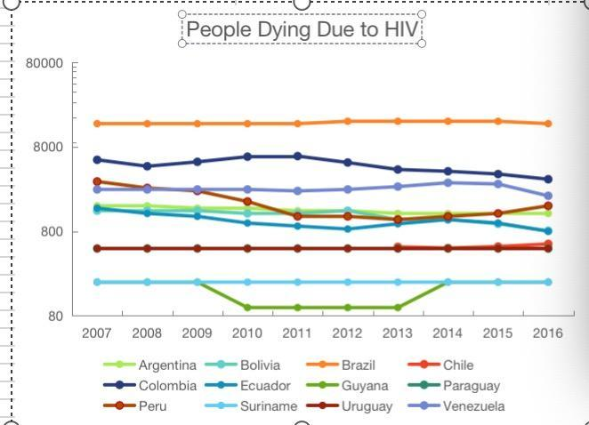

The graph above (People Dying due to HIV) shows the number of deaths due to HIV in these countries. The greatest number of people who died due to HIV in Brazil which is more than 8000. This result, associated with the finding we got from the first graph, came over reasonably. However, it's a little bit different when we pay attention to other countries. People who died due to HIV in Peru experienced a huge attenuation from 2009 to 2011, and in Guyana, there’s also a decrease starting from 2009, but this processing in Guyana ended by 2014. At that time the data trends increased back.

3.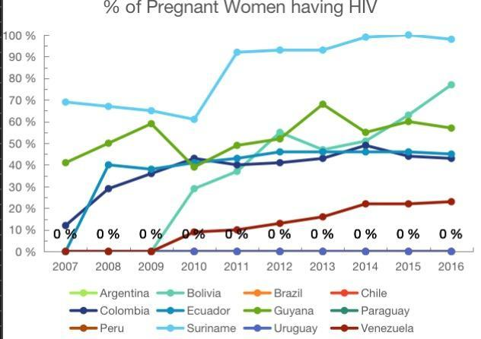

The given line chart (percentage of pregnant women having HIV) illustrates the percentage of infected pregnant women in several countries. Compared with the absolute value, the percentage can be used as a more intuitive comparison to observe the probability of pregnant women infected with HIV in various countries. This obviously helps us to make clear comparisons. The percentage of Pregnant women having HIV in Suriname shows a slight decline from 2007 to 2010, a huge rise happened in the next year and continued till the end. Suriname is also the country where the most proportion of pregnant women got HIV. On the other side, Uruguay kept nearly 0 percent in these years, which is the lowest in this area, and Venezuela also did a great job.

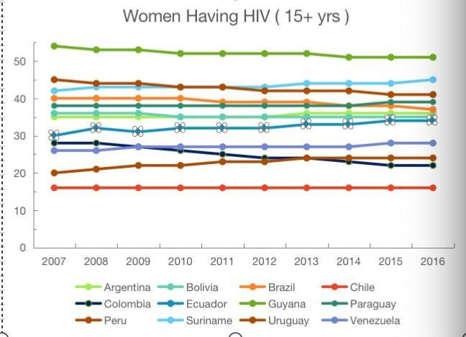

4. The line chart (Women having HIV older than 15) gives information on the number of women (15 and older) infected by HIV. From this graph, Guyana shows the highest rate at, and Brazil is the lowest. All the countries kept stable in these years. Which is slightly different from the former graph we got from pregnant women. In that graph, Suriname is the highest and Guyana’s the one below it.

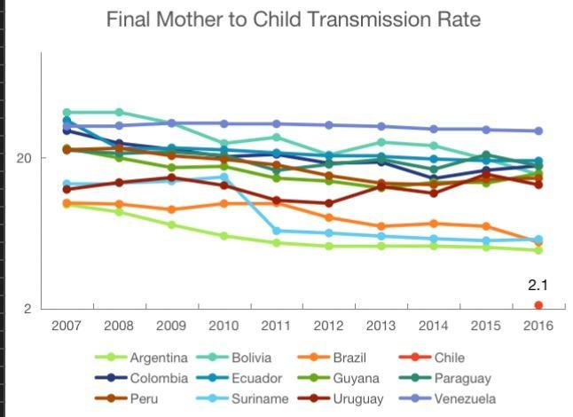

The graph (Final mother-to-child transmission rate) indicates the data on the mother-to-child transmission rate in such countries. A huge drop happened in Suriname from 2010 to 2011, which is consistent with the results we observed on the way before about women infected with AIDS. Almost all the given countries show an overall downward trend, in addition to Venezuela and Uruguay show a slight upward trend from 2007 to 2009, and then both also decline. In general, Venezuela has the highest proportion and Argentina the lowest.

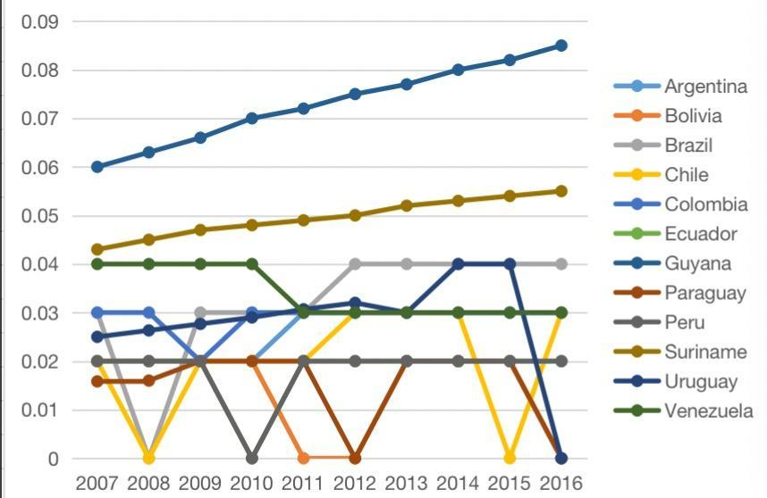

This line chart illustrates the percentage of people having HIV in these countries. Guyana showed the highest rate and maintained it over the time we studied. This trend is still growing and far higher than that of other South American countries. According to the above pictures, the situation of AIDS in Guyana is not optimistic.

**Analysis 2**

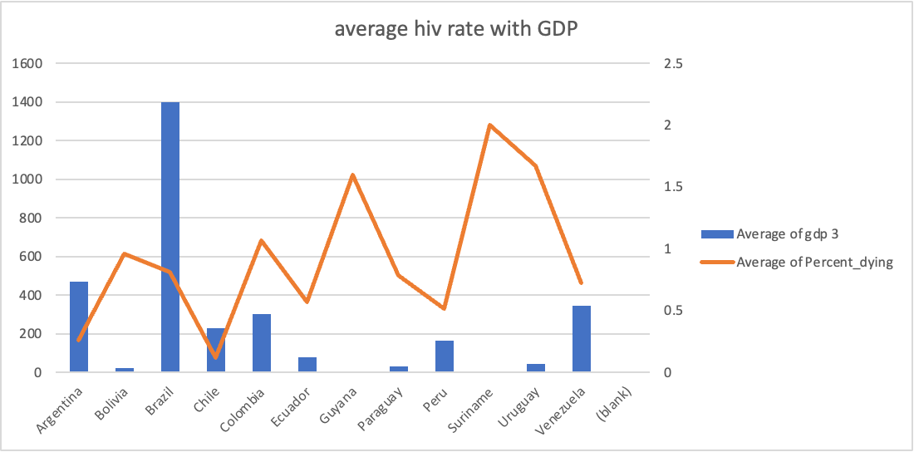

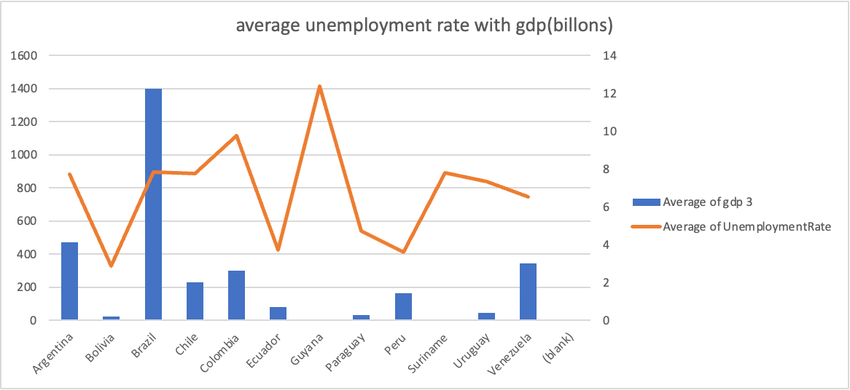

the chart above shows the average unemployment rate with the GDP in 10 years. unemployment rate shows that unemployment is been lower when the GDP is higher, except for Bolivia.

**Recommendation:**

* This analysis leads us to believe that the governments of Latin American nations still need to focus on economic development initiatives to enhance the economy, as it significantly impacts the population's health practices.
* More babies will be born HIV-free with a lower risk of their becoming infected or susceptible to HIV because of economic development, which can also result in lower rates of mother-to-child transmission.
* Although there is no clear link between the number of HIV-related deaths and the unemployment rate in Colombia, there is undoubtedly one in Peru. As a result, steps must be taken to both reduce the number of HIV-related deaths and give the populace access to employment possibilities.
* Additionally, With the country's growing population and the rise in HIV infections, there is also a significant pattern. Therefore, the government should prioritize population control measures to protect citizens' health, which greatly impacts employment and considerably boosts the economy.

**Reference:**

**• World bank. (n.d.). World Development Indicators | Databank.**

[**https://databank.worldbank.org/source/world-development-indicators**](https://databank.worldbank.org/source/world-development-indicators)

**• UNICEF. HIV/AIDS data. UNICEF DATA**

[**https://data.unicef.org/resources/data_explorer/unicef_f/**](https://data.unicef.org/resources/data_explorer/unicef_f/)

**• UNICEF. Gender and HIV/AIDS. UNICEF DATA.**

[**https://data.unicef.org/resources/data_explorer/unicef_f/?ag=UNICEF&df=HIV_AIDS**](https://data.unicef.org/resources/data_explorer/unicef_f/?ag=UNICEF&df=HIV_AIDS)

[**https://databank.worldbank.org/source/world-development-indicators#**](https://databank.worldbank.org/source/world-development-indicators)

**• WHO. (n.d.). HIV data and statistics. from**

[**https://www.who.int/teams/global-hiv-hepatitis-and-stis-programmes/hiv/strategic-information/hiv-data-and-statistics**](https://www.who.int/teams/global-hiv-hepatitis-and-stis-programmes/hiv/strategic-information/hiv-data-and-statistics)